# SWARM PROPELLED AUTONOMOUS CELESTIAL EXPLORATORY ROBOTS

**1.**Inderpreet Singh,**2.** Harjot Singh Gill**, 3.** Preetinder Singh, 4. Orsu Vinay, **5.** Sankhyadip Paul, **6**. Ajay Kumar**, 7.** Bhanu prasad**.**

*1,2,3,4,5,6,7****,*** *Department of Mechatronics Engineering, Chandigarh University Mohali, Punjab, India*

***1.[inderpreetsingh@gmail.com](mailto:inderpreetsingh@gmail.com),2.harjot.gill@gmail.com*,3.*preetmechatronics@gmail.com*** [**4.vinnuhai123q@gmail.com**](mailto:4.vinnuhai123q@gmail.com)**,[5.](mailto:5.sankyadip@gmail.com)**[**sankyadip@gmail.com**](mailto:5.sankyadip@gmail.com)**,[6.](mailto:6.bhanuprasad@gmail.com)**[**bhanuprasad@gmail.com**](mailto:6.bhanuprasad@gmail.com)**,** [**7.ajaykumar@gmail.com**](mailto:7.ajaykumar@gmail.com)

*Corresponding author: inderpreetsingh@gmail.com*

***Abstract*—** Our project Swarm Propelled Autonomous Celestial Exploratory Robots (S.P.A.C.E.R.) is a swarm project in which each robot has the special feature of defying gravity. It can move up the steep mountain and down the trench as well as underwater and overwater. It can do so with the help of a brushless motor. Because of its ability to climb steep slopes, it can access different layers of steep mountains and trenches and thus can acquire information from there. It can extract information about earth or any other planet. In this way, it can open new doors in the field of space research.

***Keywords-****swarm propelled; robot; defying gravity; brushless motor* ***ESC (electronic speed controller);***

## I. INTRODUCTION

Robots have been created to assist or replace humans in various dangerous and difficult tasks. Robots have been used in construction, manufacturing, security, etc. This is because they are able to adapt to different environments and situations. They have conquered nearly all environments that humans have put them through. Climbing robots can be used on artificial surfaces like a wall, or on natural surfaces like trees or cave walls. They are desirable for several applications such as search and rescue. This phenomenon is still a challenge to be achieved using robotic devices. Climbing robots should have some practical utility to deal with different surfaces and geometries. rack detection is important for the inspection, diagnosis, and maintenance of concrete structures. When the state of cracks generated on the surface of a comparatively large-sized concrete structure which has a height of several meters, for example, the concrete structure such as dam, buildings, bridges, towers and the like, is inspected, usually, a worker checks the cracks with eyes and makes sketches in handwriting. The inspection and maintenance work involves a large number of highly dangerous human operations. The high complexity of construction sites and environments, such as buildings, bridges, towers, dams, etc demands autonomous climbing robots with a high level of mobility. For safety and accurate detection of cracks the wall climbing robots/devices are used. to be applicable in real life. Most wall climbing robots can either climb

smooth surfaces or non-smooth surfaces. Not many robots can climb both types of surfaces. The majority of the robots in existence can only climb smooth surfaces. Researchers use nature as inspiration in designing their robots. They try to mimic nature’s surface climbers such as insects, reptiles and worms. Most researchers try to mimic spiders who they believe to be one of the most versatile wall climbers.

### II. SYSTEM DESIGN

#### A. Mechanical design

Figure 1 shows different views of the general structure of the generatively designed body of our project which we indeed made for 3D printing. The purpose of this design is to make sure that the weight of the robot body is the least possible but maintaining a good amount of durability and factor of safety. By using aluminium as a material we can easily do the weight reduction. as 3d printing is still new to industry and costs a lot so it was practically impossible for students like us to afford it due to which we made our body out of sun board for making our first prototype and proof of concept model. The main body of the robot is able to carry, all the electronic components including propeller with 2600Kv brushless motor and it’s Esc.because we are using li-ion cells instead of li- polymer battery pack the weight of our battery was alone 1.5Kg alone, hence we decided to keep it outside the body for our 1st prototype as shown in fig.4.

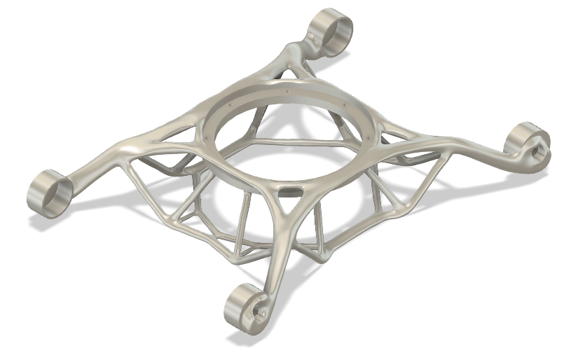

Figure 1: 3-D design of the interior body



### Figure 2: Generative layout of the interior design

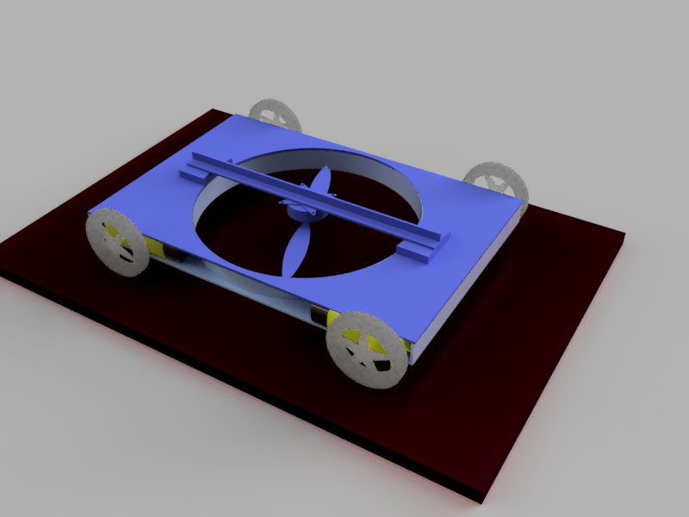

Figure 3: 3-d design of the basic model of the project version 0.

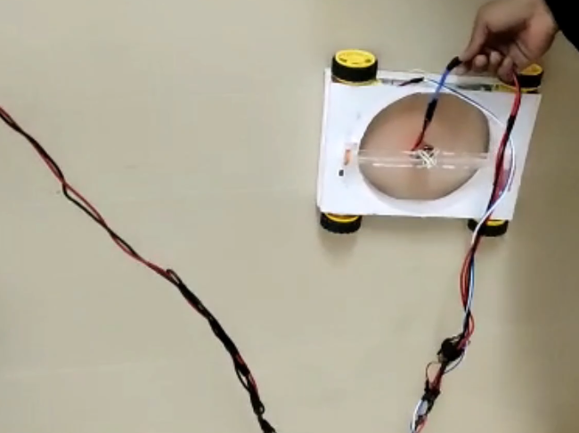

Figure 4: Actual robot project version 0 while climbing the wall.

#### B. Robot Mechanism

. A brushless propeller -based wall climbing device for concrete surface crack inspection, the wall climbing

device comprising:

- a drive unit for climbing over the wall, wherein the drive unit includes plurality of dc motor, at least

one brushless propeller, plurality of driving wheel,2600Kv brushless motor, ESC (Electronic speed control) 30 Amps and Li-ion battery;

- the plurality of dc motor positioned at each corner of the wall climbing device to drive plurality of

wheels which help climbing over the wall;

- the brushless DC motor positioned at the core of the wall climbing device to drive the duct fan with

high torque which provides effective thrust to hold the wall climbing device to the wall surface;

- the electronic speed control is an electronic circuit which is used to vary the electric motor s speed

and act as a dynamic brake; and

- the Li-ion batteries for powering the electronic speed control (ESC), and

- a capturing unit to capture cracks over the concrete surface wall, wherein the capturing unit

2. The device as claimed in claim 1, wherein the duct fan provides frictional force between the four

wheels and the concrete wall surface which counterbalances the weight of the device.

3. The device as claimed in claim 1, wherein the friction force of the duct fan depends on the nature

of the concrete wall surface and it is varied by adjusting the speed of the duct fan.

4. The device as claimed in claim 1, wherein the propeller is of 7 inch with 2 fins/ blades and gives a maximum speed

of 31000 rpm and a thrust of 850g.

5. The device as claimed in claim 1, wherein the Li- ion battery is rechargeable which powers ESC and

to other parts of devices such as the Arduino module, analog Transceiver, etc.

6. The device as claimed in claim 1, wherein the electronic speed controller powered by Li-ion

a battery (ESC) with constant current 30A is used for providing 3 phase signals to brushless motors.

7. The device as claimed in claim 1, wherein further comprises an application for wireless communication between the bot and smartphone designed by us.

control of wall climbing device which includes analog transmitter and receiver with five digitally

programmable channels out of which 4 are used for motion control and one for duct fan speed

control.

8. The device as claimed in claim 1, wherein the mapping of control signals to four dc motors and

brushless motor is done by Arduino module which receives input signals from the analog transceiver comprising NRF 24L01 module for RF communication

and it sends control signals to the drive circuit as well as ESC.

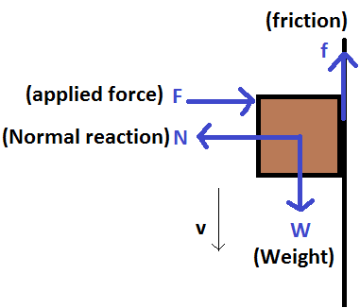

### Figure 4: process behind the idea of the bot.

#### D. Electronic Designs

The electronic design of the robot consists of integrating circuits that perform different functions. We are using Arduino nano as our main microcontroller. Besides that we have also included another Arduino nano which is actually connected to a NRF24L01 module; this is done to achieve the SWARM nature of our project. Many projects that require an embedded system with some level of intelligence can use a BASIC Stamp module as the controller. Each BASIC Stamp comes with a BASIC Interpreter chip, internal memory (RAM and EEPROM), a 5-volt regulator, a number of general-purpose I/O pins (TTL-level, 0-5 volts), and a set of built-in commands for math and I/O pin operations. BASIC Stamp modules are capable of running a few thousand instructions per second and are programmed with a simplified, b\ut customized form of the BASIC programming language, called PBASIC. The Basic Stamp BS2 modules can be connected either by using serial ports or USB. The programs are transferred through these ports and stored in the basic stamp. ,

III. PROGRAM FLOW AND ROBOT MOVEMENT

The program allows the robot to move in all the four directions based upon the inputs given by the Bluetooth client. It follows a strict sequence in order to ensure the robot’s stability. The spacer program contains several subprograms that control the overall motion of the robot.

Firstly, we connect our bot to our Bluetooth enabled smartphone having Bluetooth application which is also made and designed by our group. Then we pair our bot with the client by clicking on the connect the robot button provided. After a successful connection now, our bot is ready to listen to all the commands which are delivered from our smartphone.

*Forward Motion / Backward motion*

In order to attain such motion, we have added dedicated buttons into the application itself as shown below.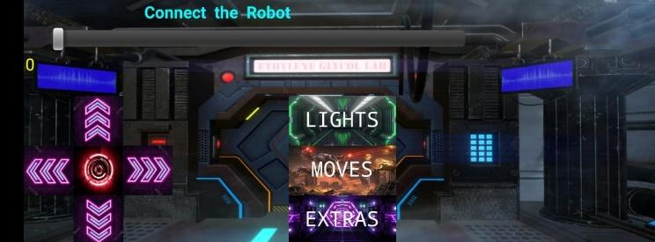

Figure 5: APP screening and operating remotely.

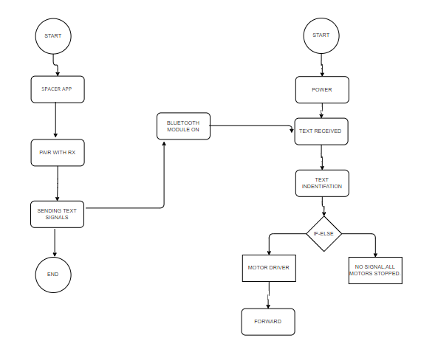

Figure 6: Block diagram of the program.

### 

The upward arrow keys you see into the picture are kept for attaining forward motion.

Whenever we press this button there’s a strict sequence of backend code which executes. its execution is done and processed by Arduino pro mini which we have embedded into our project as our main microcontroller. The sequence which executes after pressing the keys initiates by sending a text-based signal from our smartphone to the microcontroller. Let's say the text signal was ‘A’. Then this signal is received by our microcontroller via Bluetooth. Then our processor recognises the text and identifies it as ‘A’. after this a sub program initiates its execution which includes if statements.

For e.g. If we receive ‘A’ then give a HIGH signal to pin 2 and 3 and simultaneously make pin 4 and 5 LOW. Whereas if we receive a signal as ‘B’ then make all the pins 2,3,4and 5 as LOW.

After this, these HIGH, LOW values of the pins are delivered to the motor driver and it changes the motor states from no motion to forward motion.

Similarly, in order to attain the Backward motion a similar code is executed just the values of the pins 2,3,4 and 5 are interchanger from HIGH to LOW.

IV. CONCLUSIONS

The design and fabrication of the spacer has been successfully achieved and the robot has been tested multiple times on surfaces exactly 90 degrees perpendicular to the ground. A lot of customization was required in order to achieve vertical stabilization and sticking to walls. We designed our custom tyres specially for smooth surfaces like tiles in order to show bot climbing. However, we expect our robot to work in extra terrestrial missions where we expect surfaces to be very rough and rugged.

We also discovered that the brushless propeller takes a lot of power when connected to multiple circuits due to which other circuitry may experience power losses at times, but we found the solution by providing a 3.3V supply from the battery by stepping down and using buck converters of voltage regulators. However, these batteries deplete very quickly and are costly. It is recommended that another more powerful rechargeable battery be used as a supply. The battery should also be lightweight so that the torque on the motors is small. The 12V Li polymer battery we found was perfect for such applications where high discharge rate is a major concern.At the end, our first prototype of SPACER was a huge success and we successfully proved the concept of working in real life environment.

## REFERENCES

1. Maki K. Habib, “Omni Directional Robot That Can Climb A Wall”, 6th Intl Conf. on Mechatronic Technology, Kitakyushu, Japan, 2002.
2. M. Murphy, M. Sitti, “Waalbot: An Agile Semiautonomous Wall Climbing Robot”
3. Chun- Hung Chen, Vijay Kumar, “Motion Planning of Walking Robots in Environment with Uncertainty”
4. C. Menon, M. Murphy, M. Sitti, “Gecko Inspired Surface Climbing Robots” IEEE Intl Conf. on Robotics and Biomimetics (ROBIO), Shenyang, China, 2004.
5. Tomoshisa OHMORI, Peng Chen, “Walking Control method for Quadruped Robot by Genetic Algorithms”,

6th Intl Conf. on Mechatronic Technology, Kitakyushu, Japan, 2002.

1. L. Briones, P. Bustamante, and M. Serna (1994) ROBICEN: A wall-climbing pneumatic robot for inspection in nuclear power plants. Robotics and Computer-Integrated Manufacturing 11, 287-292.
2. Z. Yan Zeng, S. Hao, and W. Yan (1999) Wall-climbing robot with negative pressure sucker used for cleaning work. High Technology Letters 5, 85-88
3. L. Shuliang, Z. Yanzheng, G. Xueshan, X. Dianguo, Wang Yan (2000) A wall-climbing robot with

magnetic crawlers for sand-blasting. Spray-painting

1. T. Bretl, S. Rock, J. C. Latombe, B. Kennedy, and H. Aghazarian, “Free-Climbing with a Multi-Use Robot,” *Proceedings of the International Symposium on Experimental Robotics* (ISER), Singapore, Jun. 2004. [10] L. Guo, K. Rogers, and R. Kirkham, “A Climbing Robot with Continuous Motion,” *Proceedings of the IEEE International Conference on Robotics and*

*Automation* (ICRA ‘94), 8–13 May 1994.

[11] S. Hirose, and K. Kawabe, “Ceiling Walk of

Quadruped Wall Climbing Robot NINJA-II,”

### *Proceedings of the 1st International Conference on Walking and Climbing Robots* (CLAWAR ‘98),

Brussels, Belgium, 1998.

1. T. Yano, T. Suwa, M. Murakami, and T. Yamamoto, “Development of a Semi Self-Contained Wall Climbing Robot with Scanning Type Suction Cups,” *Proceedings of the IEEE International Conference on Intelligent Robots and Systems* (IROS ‘97), Grenoble,

France, 7–11 September, 1997.

1. R. Lal Tummala, R. Mukherjee, N. Xi, D. Aslam, H. Dulimarta, J. Xiao, M. Minor, and G. Dang, “Climbing The Walls,” *IEEE Robotics and Automation Magazine*, vol. 9, no. 4, pp. 10–19, Dec. 2002.
2. S.F. Frazier, G.S Larsen, D. Neff, L. Quimby, M. Carney, R.A. DiCaprio, S.N. Zill, “Elasticity and Movements of the Cockroach Tarsus in Walking,” *Journal of Comparative Physiology A*, vol. 185, pp.

157-172, 1999.

1. S. Hirose, A. Nagabuko, and R. Toyama, Machine That Can Walk And Climb on Floors, Walls and Ceiling, Proc. International Conference on Advanced Robotics and Automation, France, 1992.
2. M. Minor, M., H. Dulimarta, G. Danghi, R. Mukherjee, R. Lal Tummala, and D. Aslam, Design, implementation, and evaluation of an under-actuated miniature biped climbing robot, Proc. IEEE/RSJ International Conference on Intelligent Robots and Systems, 2000.
3. K. Yoneda, Y. Ota, K. Hirano, and S. Hirose, Development of a Light-Weight Wall Climbing Quadruped with Reduced Degrees of Freedom, Proc. 4th International Conference on Climbing and Walking Robots, 2001.
4. K.A. Daltorio, S. Gorb, A. Peressadko, A.D. Horchler, R.E. Ritzmann, and R.D. Quinn, A Robot that Climbs Walls using Micro-structured Polymer Feet, Proc. International Conference on Climbing and Walking Robots, London, UK, 2005.
5. K.A. Daltorio, A.D. Horchler, S. Gorb, R.E. Ritzmann, and R.D. Quinn, A Small Wall-Walking Robot with Compliant, Adhesive Feet, Proc. IEEE International Conference on Intelligent Robots and Systems, Alberta, Canada, 2005.
6. M. Spenko, M. Cutkosky, C. Majidi, R. Fearing, R. Groff, and K. Autumn, Foot design and integration for bioinspired climbing robots, Proc. SPIE Defense Security Symposium, Unmanned Systems Technology, Orlando, FL, 2006.
7. W.P. Provancher, J.E. Clark, B. Geisler, and M.R. Cutkosky, Towards Penetration-based Clawed Climbing, Int. Conf. on Climbing and Walking Robots, Madrid, Spain, 2004.

[View publication stats](https://www.researchgate.net/publication/228789074)